TITLE
Subtitle

First name Last name
Institutional affiliation (in original language) / Institutional affiliation (in English), City (in English), Country (in English)

Abstract
A short abstract (summary) of your contribution is inserted here. Please limit this to 300 words. Do not use references, footnotes or images in this section. It should be as concise as possible. It should be complete, self-explanatory and should not require reference to the paper itself. The abstract should be informative, giving the scope and emphasizing the main conclusions, results, or significance of the work described. Use verdana, 10, italic to write this part of the text.

Keywords: Maximum 5. Use verdana 10 to write this part of the text.

Subheading (if necessary)
Full papers will be published in conference proceedings.
Only papers formatted according to the guidelines indicated in this document can be accepted for publication. The other condition for publication is that at least one author of the paper is registered for the conference.
Additionally, a signed “copyright license agreement” form must be sent at the same time of the paper submission.

Paper guidlines
Please change ‘language’ in the ‘tools’ menu to UK English.
The average length of a paper should be 3500 words plus footnotes.
Please set all notes at the end of page, in Arabic numbers. Notes should be numbered sequentially throughout the article with a superscript numeral corresponding to the list of notes placed at the end. Footnotes should not be used for citations.
A maximum of 5 images can be included in the text.

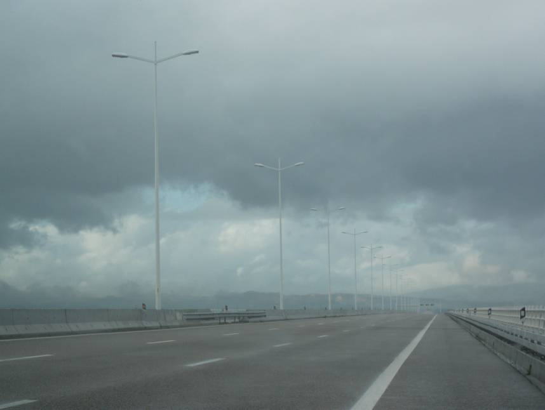
Figure 1. Each image should have a Figure Number in 10pt bold, i.e. Figure 1. Insert Title of image, brief description. (source of image following given citation style). Captions should be complete enough to allow understanding of the image without referring to the text. Centre image. Height of all images should be 10cm or less for consistency. Width of image shall be less than or equal to the width of the body text. For captions use Verdana, 10pt, single line spacing, centre aligned, justified and indented 2.5cm on left and right margins. Insert two returns after caption. Note: do not insert author/s names in captions. For example, if you are citing a work of art you created, attribute the work to ‘the author’

Expenses with images copyrights cannot be addressed to editors. Full responsibility for their publication will be credit to authors.
The final text should be sent in a Word document, formatted according to the guidelines presented in this document. Pdf documents cannot be accepted, as they cannot be drawn up for publication.
Quotations shorter than three lines should be embedded in the text, e.g. according to Lawrence J. Vale (2008: 63), ‘Quotations shorter than three lines should be embedded in the text, using italic.’ In quotations the punctuations, capitalisation and spelling of the original should be followed. Use single quotation marks, with double quotation marks only for quotations within quotations. Quotations of 50 words or more should be indented as a separate block of text without quotation marks.
Quotations of 50 words or more should be indented as a separate block of text without quotation marks. Quotations of 50 words or more should be indented as a separate block of text without quotation marks. Quotations of 50 words or more should be indented as a separate block of text without quotation marks. (Laurens, 1998, p. 25)
References should be indicated in the text by giving the author's name, with the year of publication in parentheses, e.g. Colley (1992) or (Colley, 1992). A page number must be given where a direct quotation is made, e.g. (Spate, 1994, p. 277). Within a paragraph the year may be omitted in subsequent citations of the same reference, as long as the study cannot be confused with another cited work of the same author. References to more than one publication from the same year by the same author should be distinguished as a, b, c, etc.
Acknowledgments
If included, acknowledgments should appear before the list of references. Insert here eventual references to projects or fundings (in verdana 10). Eg:
This paper is funded with FEDER funds by the Operational Competitiveness Programme – COMPETE and national funds by FCT – Fundação para a Ciência e Tecnologia within the project Popular Architecture in Portugal. A critical look (FCT: PTDC/AUR-AQI/099063)

References
All references cited in the text should be listed in full at the end of the paper in verdana 10, in the following form:
Colley, L. (1992). Britons: Forging the nation: 1707-1827. New Haven, CT: Yale University Press.
Coronil, F., & Skurski, J. (1991). Dismembering and remembering the nation: The semantics of political violence in Venezuela. Comparative Studies in Society and History, 33(2), 288-337.
Spate, O. (1994). Geography and national identity in Australia. In D. Hooson (Ed.), Geography and national identity (pp. 277-282). Oxford: Blackwell.

Author identification
Name. A short curriculum vitae of Author should be also included, 100 words Maximum.
If there is more than one author, the full text of CVs shouldn’t be longer then 200 words in verdana 10

Please don’t use footnotes to bibliographic references.

